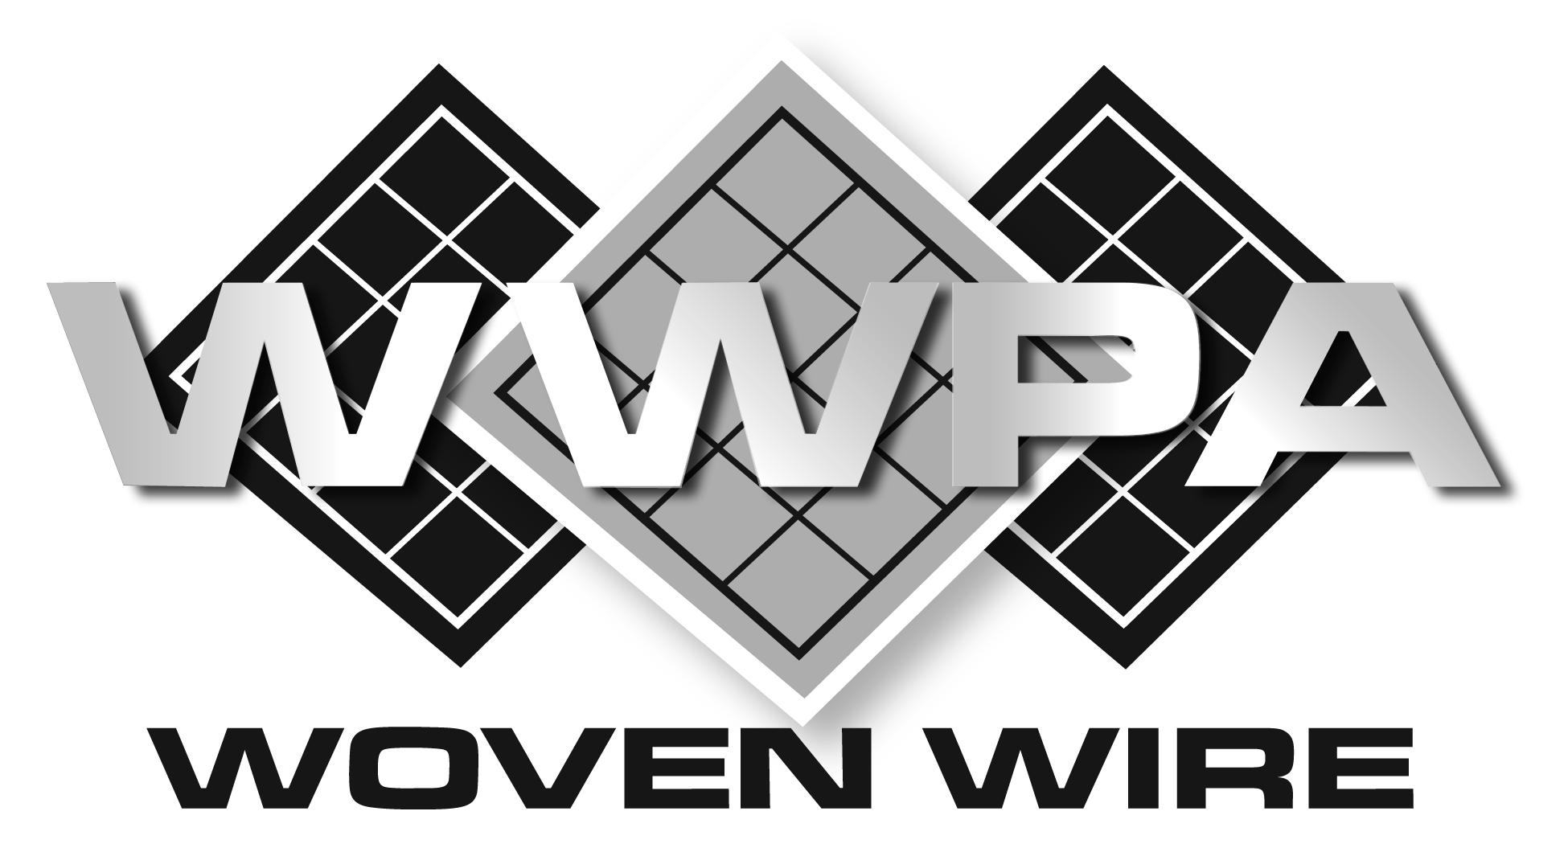

SECTION 05 73 00

RAILING INFILL PANELS

** NOTE TO SPECIFIER ** standard duty woven wire mesh partitions, storage lockers, wire mesh infill panels, window guards, and area guarding.  
   
This section is based on the products manufactured by active members of the Woven Wire Products Association. For more information, please contact:

Woven Wire Products Association

Attn: Association Treasurer

27258 Wick Rd.

Taylor MI, 48180  
 Email: [info@wovenwire.org](mailto:info@wovenwire.org)  
 Web: www.wovenwire.org  
   
The Woven Wire Products Association (WWPA) was established in 1942 as a professional association representing U.S. manufacturers of diamond woven wire mesh products. WWPA members emphasize high quality workmanship and ethical business standards, and produce woven wire products for institutional, industrial, and architectural applications.  
   
With over 1,000 years of combined experience, WWPA member companies are the preeminent manufacturers of woven wire partitions, window guarding, and railing infill panels. Architects and general contractors have trusted the WWPA over the years to deliver high quality products, along with exact specifications to match the needs of their active projects.

.

1. GENERAL
   1. SUMMARY
      1. Wire Mesh Hand Railing Infill Panels
   2. RELATED DOCUMENTS

** NOTE TO SPECIFIER ** Delete any sections below not relevant to this project; add others as required.

* + 1. Drawings and general provisions of the Contract, including General and Supplementary Conditions and Division 01 Specification Sections, apply to this Section.
  1. SUBMITTALS
     1. Submit under provisions of Section 01 30 00.
     2. Product Data: Manufacturer's data sheets on each product to be used, including:
        1. Detailed specification of construction and fabrication.
        2. Manufacturer's installation instructions.
        3. Preparation instructions and recommendations.
        4. Storage and handling requirements and recommendations.
     3. Shop Drawings: Indicate dimensions, description of materials and finishes, general construction, specific modifications, component connections, and installation procedures, plus the following specific requirements.
        1. Provide location template drawings for items supported or anchored to permanent construction.

** NOTE TO SPECIFIER ** Delete selection samples if colors have already been selected.

* + 1. Selection Samples: For each finish product specified, two complete sets of color chips representing manufacturer's full range of available colors and patterns.
  1. QUALITY ASSURANCE
     1. Installer Qualifications
        1. Construct areas designated by Architect.
        2. Do not proceed with remaining work until workmanship, color, and sheen are approved by Architect.
        3. Repair and correct mock-up area as required to produce acceptable work.
     2. Design Requirements:
        1. Design railing infill panel system to provide for movement of components without damage, undue stress on fasteners or other detrimental effects, when subject to design loads.
        2. Design system to accommodate construction tolerances, deflection of building structural members, and clearances of intended openings.
        3. All panels meet building code loading requirements.
     3. Source Limitations: Obtain wire mesh items for single source from single manufacturer.
  2. DELIVERY, STORAGE, AND HANDLING
     1. Store products in manufacturer's unopened packaging until ready for installation.

** NOTE TO SPECIFIER ** Delete items below not required for project. Wrapping and packaging as detailed below may require additional costs.

* + - 1. Materials may ship uncrated per Manufacturer’s recommendation in order to maximize volume on common carrier and to reduce freight cost.
      2. Materials to be crated or palletized with cardboard protectors on perimeters of panels and doors and strapped using nylon materials within crating. Crates are non-returnable and the responsibility of the customer for proper disposal.
    1. Store products in manufacturer’s unopened packaging until ready for installation.
  1. PROJECT CONDITIONS
     1. Field Measurements: Customer to verify actual dimensions of construction contiguous with wire mesh units by field measurement before fabrication.
     2. Maintain environmental conditions (temperature, humidity, and ventilation) within limits recommended by manufacturer for optimum results. Do not install products under environmental conditions outside manufacturer's absolute limits.

1. PRODUCTS
   1. MANUFACTURERS
      1. Acceptable Manufacturers: Active members, in good standing, with the Woven Wire Products Association (WWPA), [www.wovenwire.org](http://www.wovenwire.org/):

** NOTE TO SPECIFIER ** We suggest you verify the member is still in good standing to be considered for solicitation by reviewing our active member list at www.wovenwire.org

* + - 1. Apex Iron Works
      2. G-S Company, The
      3. Indiana Wire Products
      4. Newark Wire Works, Inc.
      5. SpaceGuard Products, Inc.
      6. Standard Wire & Steel Works
      7. Wire & Iron Products (WIPCO), a Division of Jesco Industries, Inc.
    1. Substitutions: Not permitted if only considering materials certified by the Woven Wire Products Association
  1. MATERIALS
     1. Steel Wire: ASTM A 510 (ASTM A 510M).
     2. Steel Plates, Channels, Angles, and Bars: ASTM A 36/A 36M.
  2. PRODUCT
     1. Mesh: No. 6 gauge, steel wire triple crimped and woven into 2 inch square mesh pattern.
     2. Horizontal Frames: 1 inch by 1/2 inch by 1/8 inch steel channel.
     3. Vertical Frames: 1 inch by 1/2 inch by 1/8 inch steel channel.
     4. Flat Closure Bar: 1/8 inch by 1 inch cold rolled steel flat welded to face of horizontal and vertical frames to enclose wire
     5. Railing Connection:

** NOTE TO SPECIFIER ** Delete all but railing connection required.

* + - 1. Round: 3/8 inch diameter rod welded to flat closure bar and rail frame. Refer to drawing for length.
      2. Flat: 2 inch wide flat tabs welded to flat closure bar and rail frame. Refer to drawing for length.
    1. Finish:

** NOTE TO SPECIFIER ** Delete all except the required finish.

* + - 1. Powder coated in manufacturer’s standard gray or black.
      2. Powder coated in color as selected by Architect from manufacturer’s standard color chart.
      3. Sprayed enamel in manufacturer’s standard gray or black.
      4. Sprayed enamel in color as selected by Architect from manufacturer’s standard color chart.
      5. Hot-Dipped Galvanized
  1. FABRICATION
     1. Fabricate assemblies of framed sections; to sizes and profiles required; with framing members fitted, reinforced and braced to suit design requirements.
     2. Fit and assemble in largest practical sections for delivery to Project Site, ready for installation.
     3. Fabricate items with joints tightly fitted and secured.
     4. Grind exposed welds smooth and flush with adjacent finish surface. Ease exposed edges to small uniform radius.
     5. Make exposed joints flush and hairline.
  2. FINISH
     1. Clean surfaces of rust, scale, grease, and foreign matter before finishing. Clean material using a two to three stage wash system immediately prior to finishing.
     2. Prefinished Surfaces: Material to be prime coated if required prior to finishing.

1. EXECUTION
   1. EXAMINATION
      1. Verification of Conditions: Examine areas and conditions under which Work is to be performed and identify conditions detrimental to proper or timely completion.
         1. Do not proceed until unsatisfactory conditions have been corrected.
   2. INSTALLATION
      1. Comply with manufacturer's recommendations.
      2. Panels to be mechanically fastened or welded to rail structure in field as indicated on detail drawings.
      3. Install panels plumb, accurately fitted, properly aligned, securely fastened or welded in place, and free from distortion or detects.
   3. TOLERANCES
      1. Maximum Variation from Plumb or Level: 1/4 inch (6 mm).
      2. Maximum Misalignment from True Position: 1/4 inch (6 mm).
   4. PROTECTION
      1. Touch-up, repair or replace damaged products before Substantial Completion.

END OF SECTION